|  |  |  |  |  |  |
| --- | --- | --- | --- | --- | --- |
| Date | 30-Nov-22 | | | Tester Name | Mayuri Patel |
| Environment | Penfax - Test | | | Login used |  |
| Operating System | Select OS | Version: | Update: | | |
| Software Used | Select Software | Version: | Update: | | |
| Select Software | Version: | Update: | | |
| Release version | 22.4.1 | | | | |
| Title |  | | | | |
| Test Type | Regression | | | | |
| Test Scenario | Change Payment Instructions | | | | |
|  |  | | | | |
| Expected Results |  | | | | |
| Pass/Fail | Pass | | | JIRA# | N/A |

Describe your steps with screenshots:

Search a member to change Payment Instruction

Open that member Profile

Go to Investment under Member Profile

Account Instructions 🡪 Add new Account Instruction

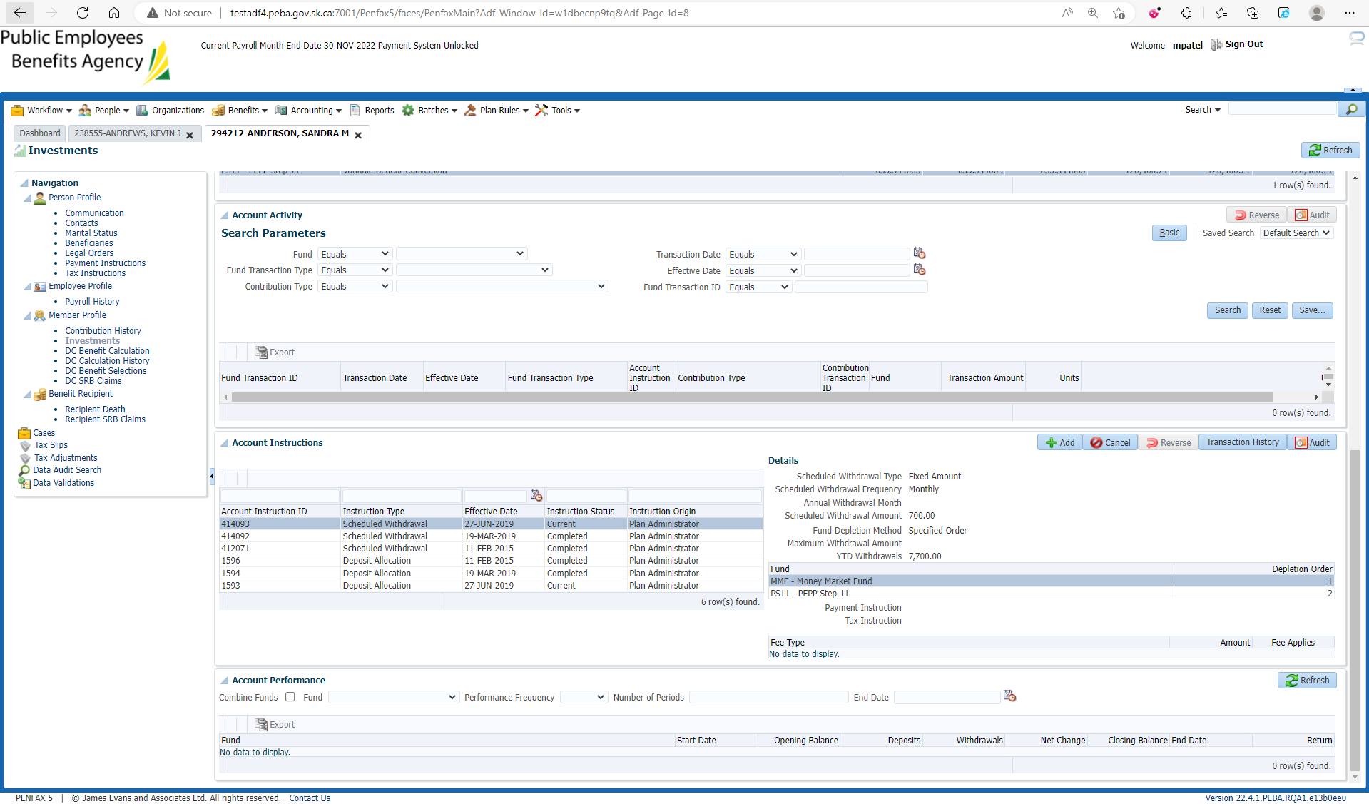

Enter required details and Save

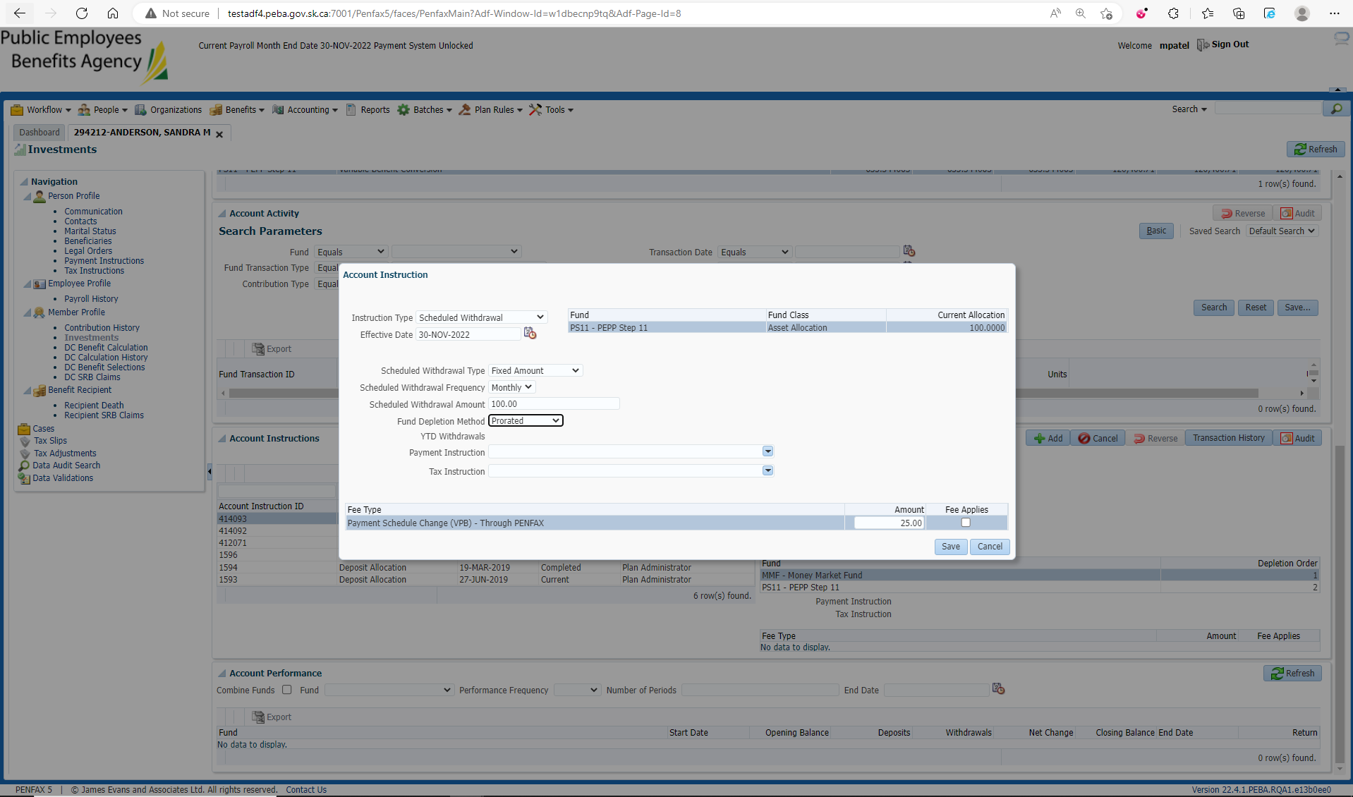

Old Instruction is now Completed and newly added Instruction becomes current one

